CEP Lab 5
By:
Anthony Garcia
Josh Ignacio

Exercise 1
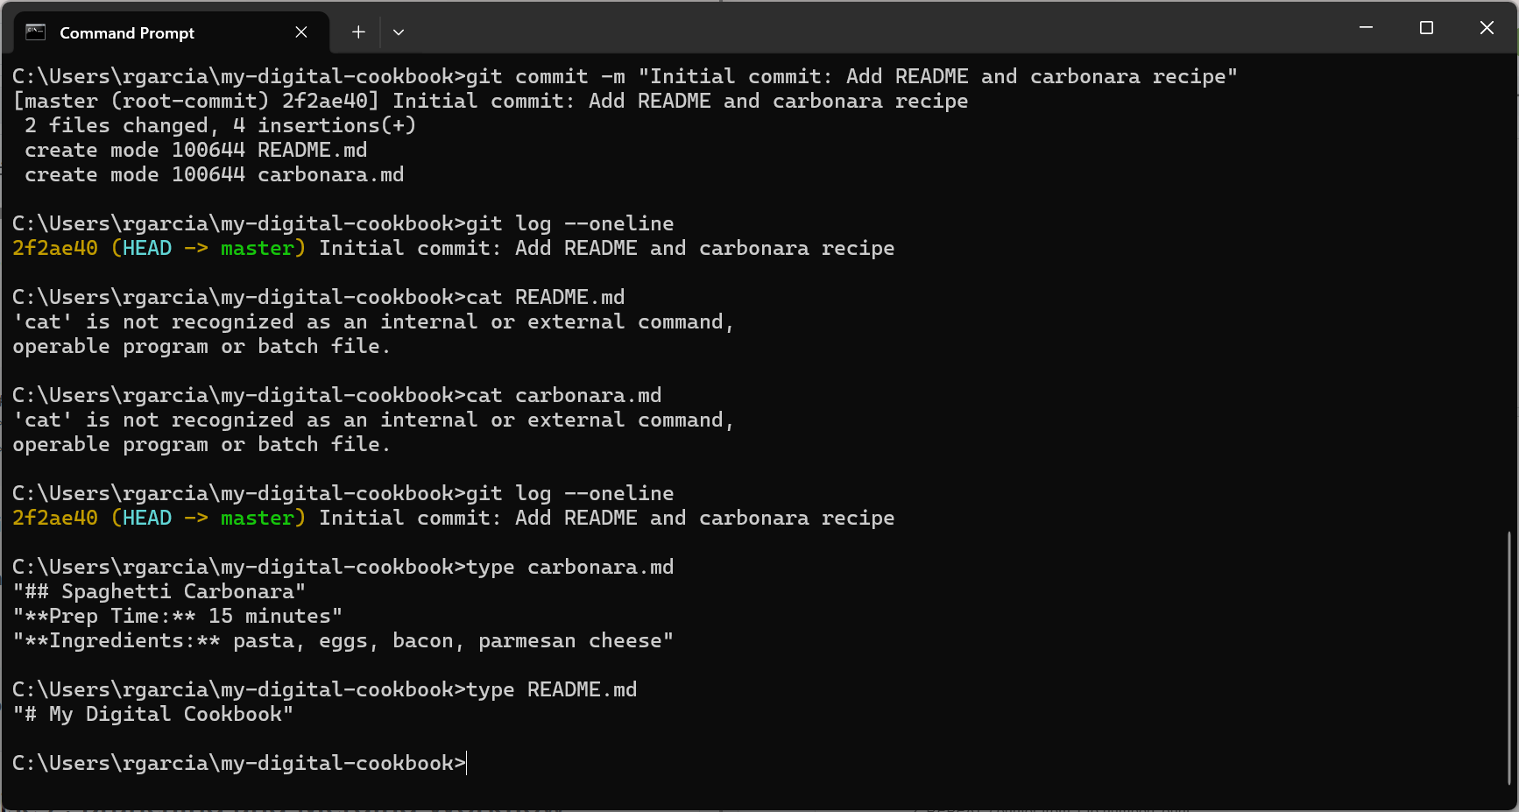

Exercise 2
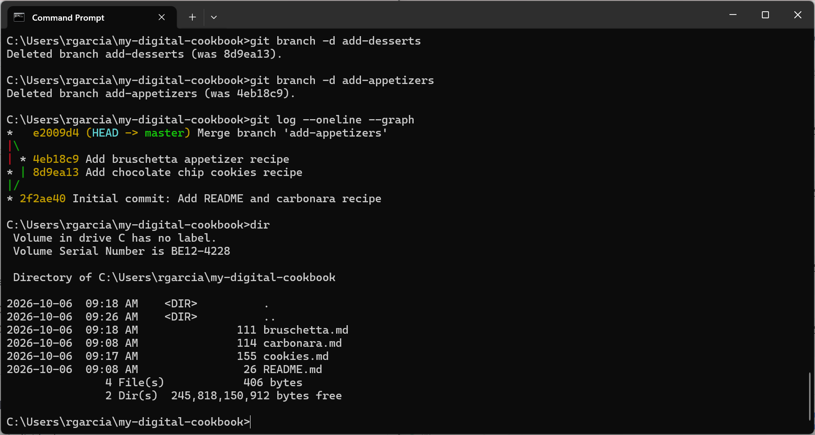

Exercise 3

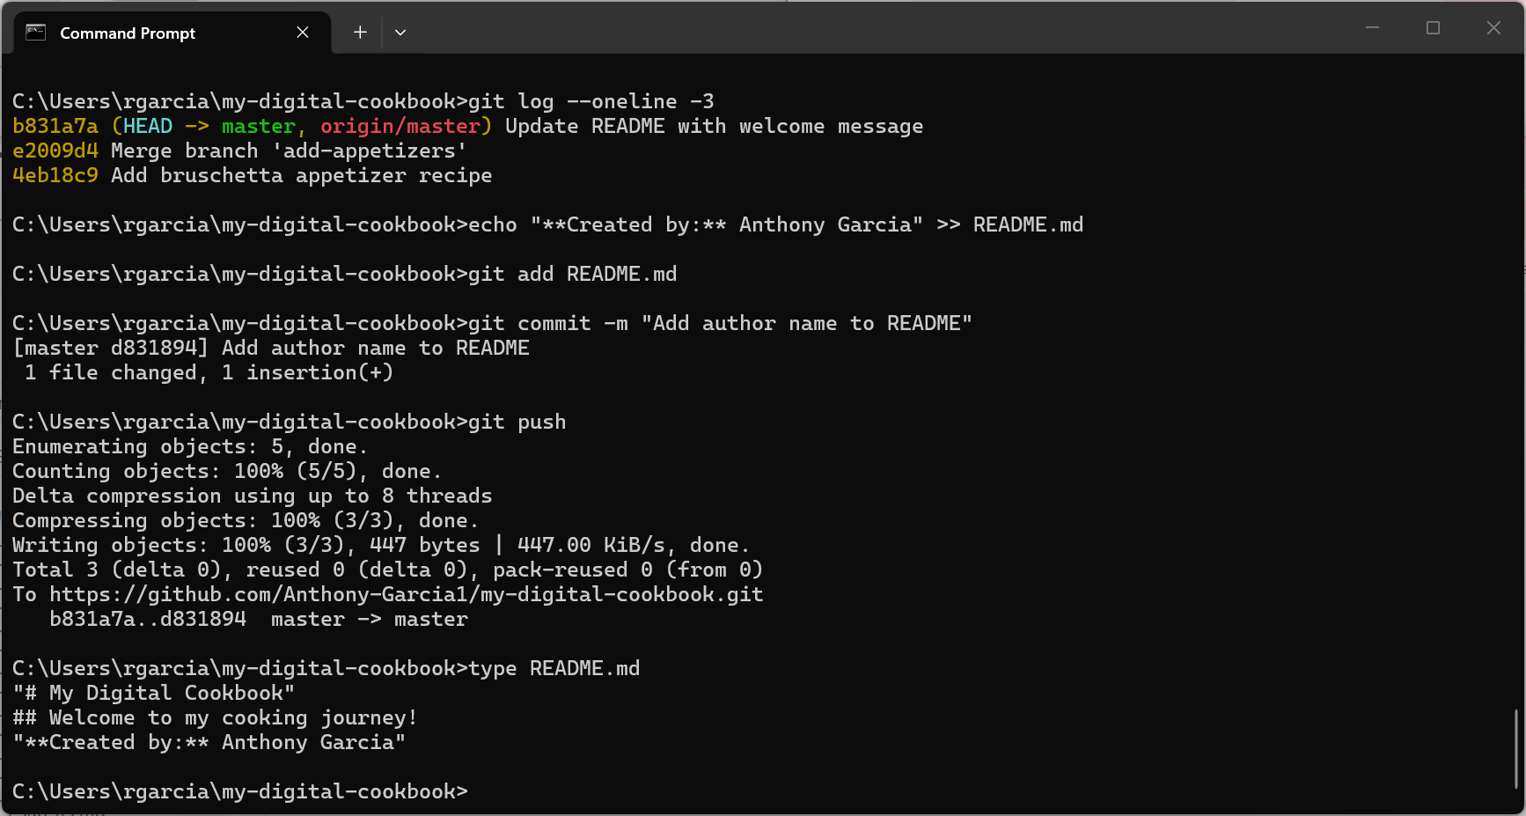
https://github.com/Anthony-Garcia1/my-digital-cookbook/

Exercise 4
Partners Github - https://github.com/joshignacio11/my-digital-cookbook

